Glue lab 2:

Step 1: create source + target buckets and upload json file to source bucket
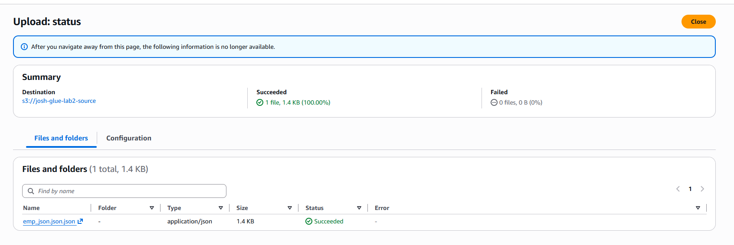

Step 2: Create role for glue to take on (im going to use the same one from earlier today, heres proof I actually made it this time as well tho)
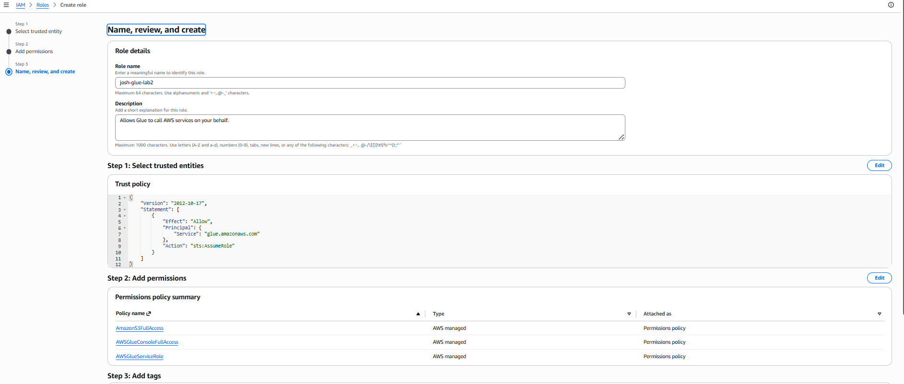

Step 3: create and visual etl
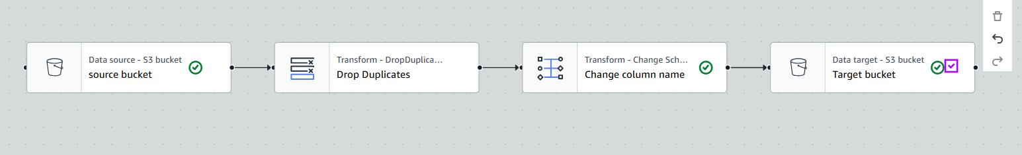
Step 4: configure visual ETL
4a. configure s3 bucket
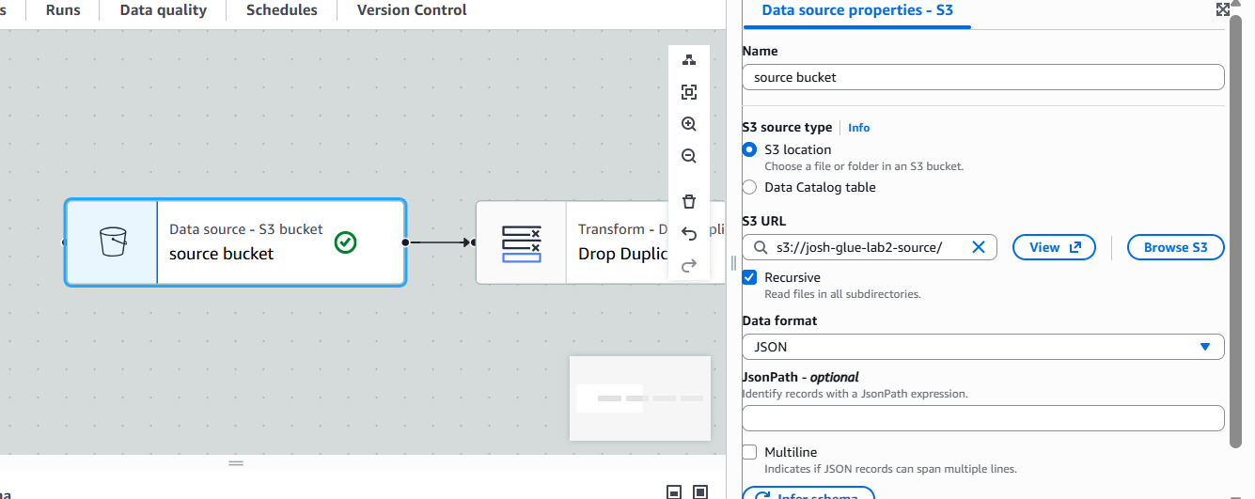
4b. configure drop duplicates
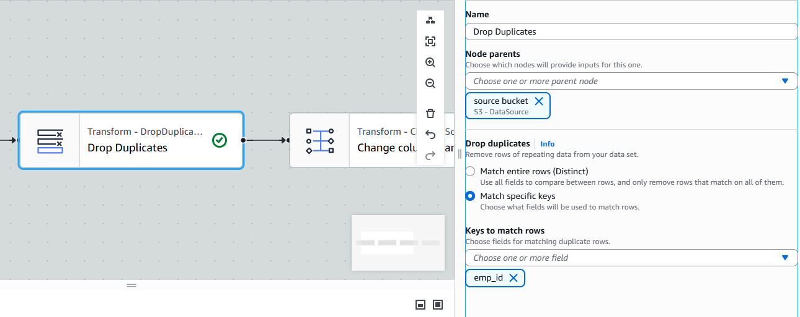
4c. change the column name from address to country

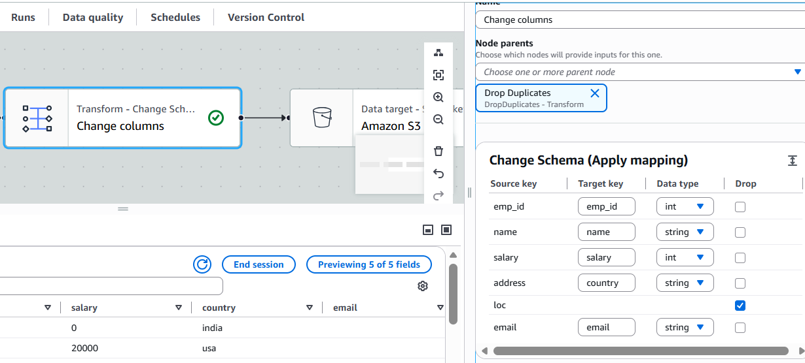
4D. Format target s3 bucket for csv
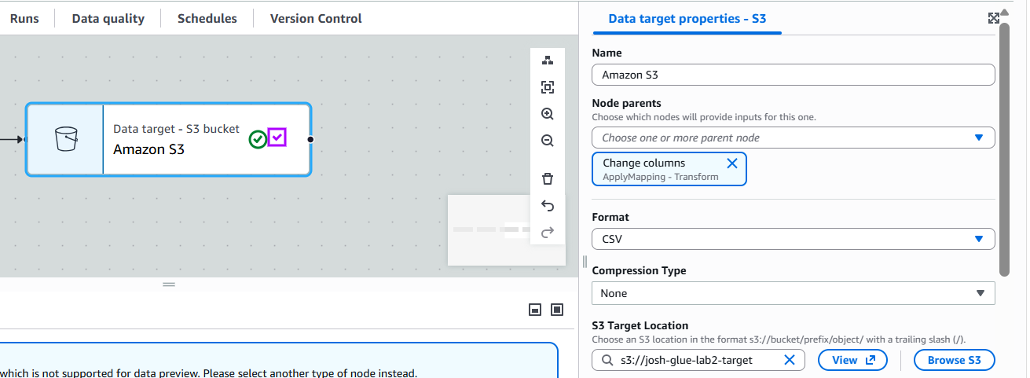
Step 5. Display results in excel
5a. download the file and rename it to a .csv file
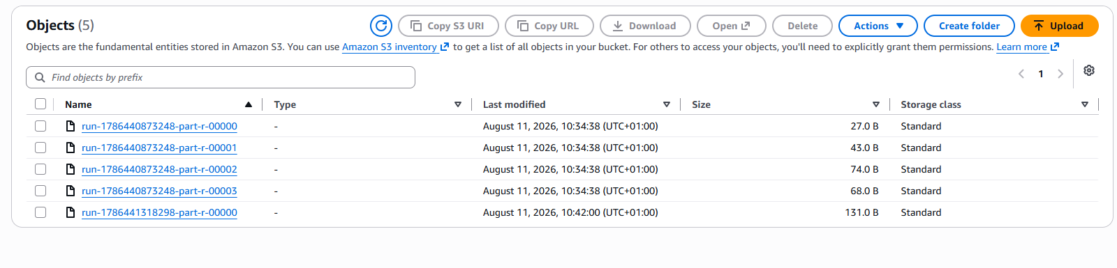
5b. open in excel
